**A Database Mini Project Report**

**On**

**“SIG Management System”**

Submitted to the

Savitribai Phule Pune University

In partial fulfillment for the award of the Degree of

Bachelor of Engineering

in

Information Technology

By

**Manas Patil (33355)**

**Niranjan Patil (33356)**

**Swapnil Patil (33358)**

**Jayesh Prajapat (33360)**

**(TE-11)**

Under the guidance of

**Prof. Sumitra Jakhete**



Department of Information Technology

Pune Institute of Computer Technology College of Engineering

Sr. No 27, Pune-Satara Road, Dhankawadi, Pune - 411 043.

**2019-2020**



**CERTIFICATE**

This is to certify that the mini project report entitled **“SIG Management System”** being submitted by **Manas Patil** **(33355)**, **Niranjan Patil** **(33356)**, **Swapnil Patil** **(33358)**, **Jayesh Prajapat** **(33360)** is a record of bonafide work carried out by them under the supervision and guidance of **Prof. Sumitra Jakhete** in partial fulfillment of the requirement for **TE (Information Technology Engineering) – 2015 course** of Savitribai Phule Pune University, Pune in the academic year 2019-2020.

Date: 16/10/2019

Place: Pune

Guide Subject Coordinator Head Of Department

Mrs. S. A. Jakhete Dr. Emmanuel Dr. A. M. Bagade

Principal

Dr. P. T. Kulkarni

This Project Based Seminar report has been examined by us as per the Savitribai Phule Pune University, Pune requirements at Pune Institute of Computer Technology, Pune – 411043 on . . . . . . . . . . . .

Internal Examiner External Examiner

**ACKNOWLEDGEMENT**

With deep sense of gratitude, we would like to thank all the people who have lit our path with their kind guidance. We are very grateful to these intellectuals who did their best to help during our project work.

The special gratitude goes to our internal Guide Mrs. Sumitra Jakhete, staff members and technical staff members, of Information Technology Department for their expensive, excellent and precious guidance in completion of this work. We also thank our subject coordinator Dr. Emmanuel for his guidance. We thank all the class colleagues for their appreciable help for our working project.

We are also thankful to our parents for providing their wishful support for our successful project completion. Lastly, we thank all our friends and the people who are directly or indirectly related to our project work.

Manas Patil (33355)

Niranjan Patil (33356)

Swapnil Patil (33358)

Jayesh Prajapat (33360)

**CONTENTS**

|  |  |  |
| --- | --- | --- |
| **Sr. No** | **TITLE** | **Page no** |
| **1.** | **Abstract** | **1** |
| **2.** | **Introduction** | **2** |
| **3.** | **Overview** | **3** |
| **4.** | **Background and Motivation** | **3** |
| **5.** | **Objective and Methodology** | **4** |
| **6.** | **Scope** | **5** |
| **7.** | **Requirements** | **6** |
| **8.** | **E-R Diagram** | **7** |
| **9.** | **Schema Diagram** | **8** |
| **10.** | **Relational Database Design** | **9** |
| **11.** | **Database Normalization** | **11** |
| **12.** | **Graphical User Interface** | **16** |
| **13.** | **Conclusion** | **22** |
| **14** | **References** | **23** |

**ABSTRACT**

In this project we have created a user friendly application for special interest group management. The system allows users from various physical locations to access a central internet based group. To create the system, we used the back-end as MySQL to store and manage all the data related to the system. And for the interface we used JSP, HTML-5, CSS-3 and Bootstrap-4. The system allows users to create new groups as per their interest. When a user creates a group he/she will get the exclusive admin rights over that group. All the users can see all the groups created in the system and join whichever they are interested in. User can take part in the interaction. Each group has three sections that are questions, posts and events. This sections carry out the core functionality of discussions of a group. The system allows users to see various events and get notifications of them as per need. The system offers an easy user friendly interface to carry out all the tasks required to efficiently carry out any kinds of tasks.

**INTRODUCATION**

Special interest groups are a crucial part of our education system. They help the students discover their interests and develop them to benefit themselves. The online sig management system ensures that all the flaws of the traditional system are overcome and new additional features are introduced.

The traditional approach to the special interest system is that students decide when to meet where to meet and then they carry out this discussion. The major problem with this system is that not all problems of students are solved. Students might have stuck across a problem while they are working on something but to plan an entire meet takes time and the student might have to waste a lot of time to solve that particular problem. Our system proposes an approach to overcome this difficulty. The system will work through internet hence any user from across the globe can access the group at any time needed. So if a student gets stuck over a problem he can just post a question in the related group and his fellow group mates can solve the problem on the same point by answering the question. Same will work with sharing new information. Students can carry out their own discussions from remote locations this will help in growing a strong knowledge base in all users. Also if there is no group that matches the users interests he can just go ahead and create one. When a user will create a group he/she will be admin of the group, and will have the exclusive admin rights over that group.

**OVERVIEW**

This report discusses the outcome achieved by the work done in development of Special Interest Group Management System using JSP ad front-end platform and MySQL as back-end platform. The system has also used HTML, CSS, Bootstrap, Java Script to design a user friendly interface. JSP provides a great facility to connect various pages and to implement the core business logic. And MySQL provides an effective database management platform that provides facility to store all the data related and required by the system.

**BACKGROUND AND MOTIVATION**

Special interest groups exhibited several defining characteristics. First, special interest groups are associations joined voluntarily by individuals sharing at least one common interest or belief that defines the group's purpose.

As earlier the people are used to form special interest groups but any information and communication related to group happen only at a physical place. To solve this problem of miscommunication and problem with any physical existence of special interest group we are creating one platform to manage all the special interest groups using the website. All the group related stuff can be shared by every group member and access it over the internet. There is no need to go anywhere, User can access it anywhere over the world. Anyone can create a new group for as per their requirements. Instead of physical conversations and discussions, people can do it here.

Most of the time people have a problem or some doubt related to some topic instead of physical interaction others can solve the problems using this platform.

**OBJECTIVES**

1. To provide a system that can be remotely accessed through the internet.
2. To implement real-time communication between users.
3. To overcome the issue of miscommunication that occurs in physical interactions.
4. To provide an easy, cost-efficient, and time-saving platform to users.
5. To enhance the knowledge base by storing all the past data that may be in the form of question-answer or post-comment.

**METHODOLOGY**

To implement the above goals, the following methodology needs to be followed:

1. Proper commendations.
2. Proper validations.
3. Go through the created schedule.
4. Proper development of a project by following SDLC.
5. Proper division of tasks between project group members.
6. Proper integration of divided tasks.
7. Proper testing for all modules individually and combined testing after integration.

**SCOPE**

Special interest groups are collection of individuals who share a specific common interest. Various interest groups can overlap. For instance, the same individual can be an entrepreneur, a programmer, a house owner and golf player.

With respect to our field, there are various students who are learning various programming languages; sometimes they have issues regarding the concept. At that time, they can communicate within the group. They can ask the questions and experts can give them solutions.

In older days you have to choose physical place for learning purpose and it required a common timing also, using this platform you can communicate from anywhere and anytime. The people from all over the world can solve their challenges by joining their interested group.

It is an interesting concept and platform that provides instant and relevant responses to your thoughts and questions by connecting you to the people who should be able to help.

The project serves as a platform for users to ask and answer questions, posts and comments and they also can include events, through membership and active participation.

### You can generate awareness and leads for your brand and products across the network of our service. Suppose one organization wants to promote their brands, we can advertise their brands on their respective groups

**REQUIREMENTS**

* Software requirements:
* Glassfish server 4.1
* Java 8
* MySQL Server
* Bootstrap/css/JQuery
* Any Operating System
* Any web browser on user side for accessing internet.
* Hardware requirements (For Server):
* Storage:
  + 2GB(Minimum)
  + 5GB(Recommended)
* Ram:
  + 1GB(Minimum)
  + 2GB(Recommended)

**E-R DIAGRAM**

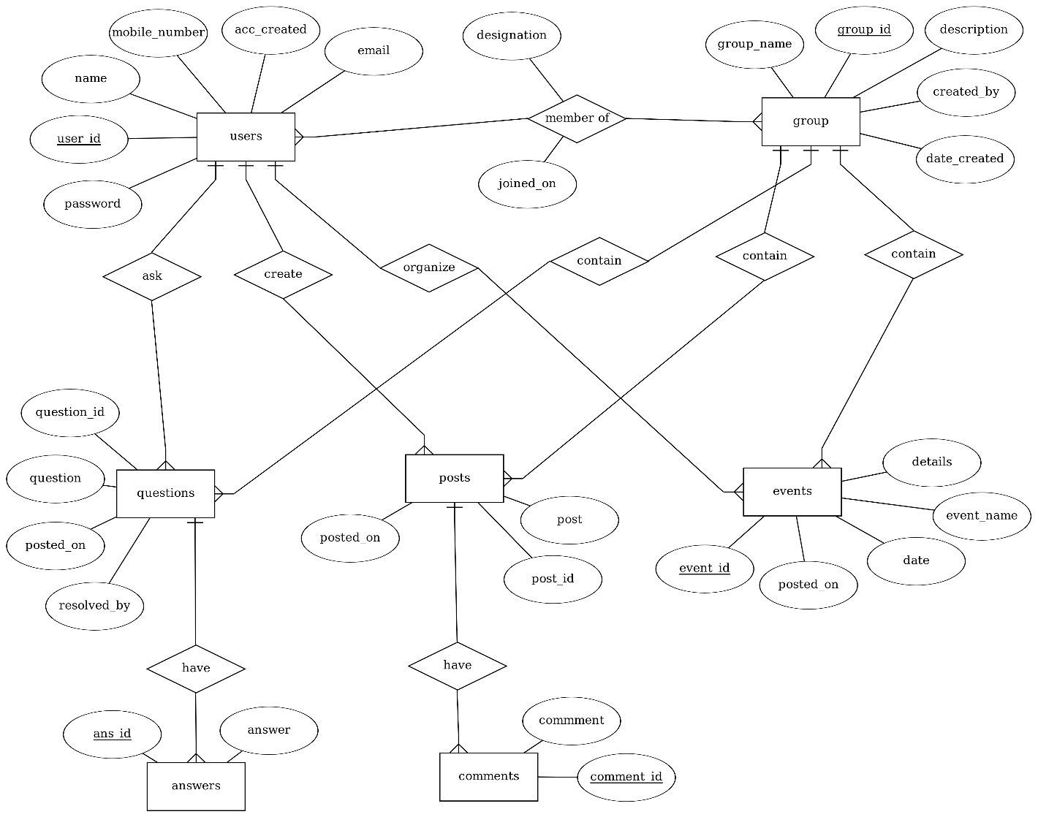

**SCHEMA DIAGRAM**

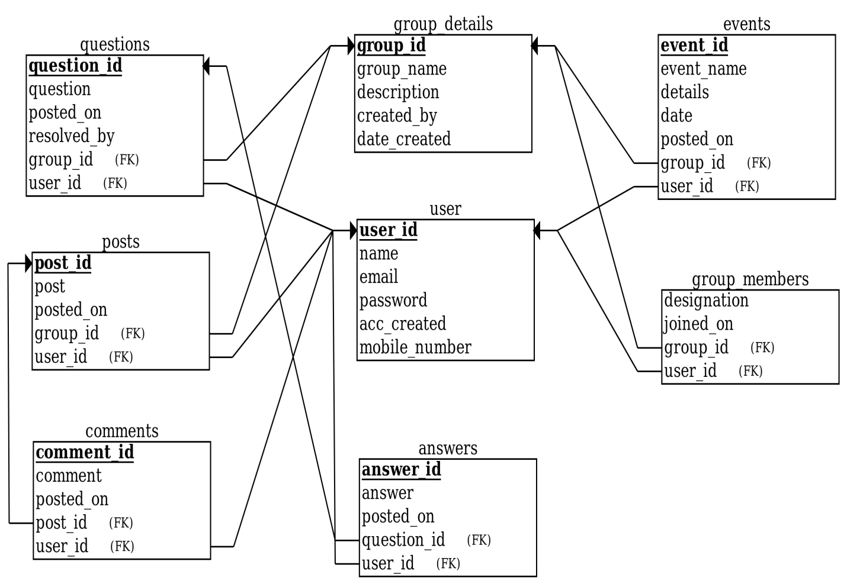

**RELATIONAL DATABASE DESIGN**

**Tables:**

**1. users:**

( user_id, name, email, password, acc_created, mobile_number )

|  |  |  |  |  |  |
| --- | --- | --- | --- | --- | --- |
| user_id | name | email | password | acc_created | mobile_number |

**2. group_details:**

( group_id, group_name, description, created_by, date_created )

|  |  |  |  |  |
| --- | --- | --- | --- | --- |
| group_id | group_name | description | created_by | date_created |

**3. group_members:**

( designation, joined_on, group_id, user_id )

|  |  |  |  |
| --- | --- | --- | --- |
| designation | joined_on | group_id | user_id |

**4. posts:**

( post_id, post, posted_on, group_id, user_id )

|  |  |  |  |  |
| --- | --- | --- | --- | --- |
| post_id | post | posted_on | group_id | user_id |

**5.comments:**

( comment_id, comment, posted_on, post_id, user_id )

|  |  |  |  |  |
| --- | --- | --- | --- | --- |
| comment_id | comment | posted_on | post_id | user_id |

**6. questions:**

( question_id, question, posted_on, resolved_by, group_id, user_id )

|  |  |  |  |  |  |
| --- | --- | --- | --- | --- | --- |
| question_id | question | posted_on | resolved_by | group_id | user_id |

**7. answers:**

( answer_id, answer, posted_on, question_id, user_id )

|  |  |  |  |  |
| --- | --- | --- | --- | --- |
| answer_id | answer | posted_on | question_id | user_id |

**8. events:**

( event_id, event_name, details, date, posted_on, group_id, user_id )

|  |  |  |  |  |  |  |
| --- | --- | --- | --- | --- | --- | --- |
| event_id | event_name | details | date | posted_on | group_id | user_id |

**DATABASE NORMALIZATION**

**1.First Normal Form:**

The relation is in 1NF if it has no repeating groups. All tables have no repeating groups so they are in 1NF.

**1. users:**

( user_id, name, email, password, acc_created, mobile_number )

|  |  |  |  |  |  |
| --- | --- | --- | --- | --- | --- |
| user_id | name | email | password | acc_created | mobile_number |

**2. group_details:**

( group_id, group_name, description, created_by, date_created )

|  |  |  |  |  |
| --- | --- | --- | --- | --- |
| group_id | group_name | description | created_by | date_created |

**3. group_members:**

( designation, joined_on, group_id, user_id )

|  |  |  |  |
| --- | --- | --- | --- |
| designation | joined_on | group_id | user_id |

**4. posts:**

( post_id, post, posted_on, group_id, user_id )

|  |  |  |  |  |
| --- | --- | --- | --- | --- |
| post_id | post | posted_on | group_id | user_id |

**5.comments:**

( comment_id, comment, posted_on, post_id, user_id )

|  |  |  |  |  |
| --- | --- | --- | --- | --- |
| comment_id | comment | posted_on | post_id | user_id |

**6. questions:**

( question_id, question, posted_on, resolved_by, group_id, user_id )

|  |  |  |  |  |  |
| --- | --- | --- | --- | --- | --- |
| question_id | question | posted_on | resolved_by | group_id | user_id |

**7. answers:**

( answer_id, answer, posted_on, question_id, user_id )

|  |  |  |  |  |
| --- | --- | --- | --- | --- |
| answer_id | answer | posted_on | question_id | user_id |

**8. events:**

( event_id, event_name, details, date, posted_on, group_id, user_id )

|  |  |  |  |  |  |  |
| --- | --- | --- | --- | --- | --- | --- |
| event_id | event_name | details | date | posted_on | group_id | user_id |

**2. Second Normal Form**

A relation is said to be in second normal form if it is already in first normal form and it has no partial dependency

The absence of partial dependency in all relations in database take them into 2NF without any modification

**1. users:**

( user_id, name, email, password, acc_created, mobile_number )

|  |  |  |  |  |  |
| --- | --- | --- | --- | --- | --- |
| user_id | name | email | password | acc_created | mobile_number |

**2. group_details:**

( group_id, group_name, description, created_by, date_created )

|  |  |  |  |  |
| --- | --- | --- | --- | --- |
| group_id | group_name | description | created_by | date_created |

**3. group_members:**

( designation, joined_on, group_id, user_id )

|  |  |  |  |
| --- | --- | --- | --- |
| designation | joined_on | group_id | user_id |

**4. posts:**

( post_id, post, posted_on, group_id, user_id )

|  |  |  |  |  |
| --- | --- | --- | --- | --- |
| post_id | post | posted_on | group_id | user_id |

**5.comments:**

( comment_id, comment, posted_on, post_id, user_id )

|  |  |  |  |  |
| --- | --- | --- | --- | --- |
| comment_id | comment | posted_on | post_id | user_id |

**6. questions:**

( question_id, question, posted_on, resolved_by, group_id, user_id )

|  |  |  |  |  |  |
| --- | --- | --- | --- | --- | --- |
| question_id | question | posted_on | resolved_by | group_id | user_id |

**7. answers:**

( answer_id, answer, posted_on, question_id, user_id )

|  |  |  |  |  |
| --- | --- | --- | --- | --- |
| answer_id | answer | posted_on | question_id | user_id |

**8. events:**

( event_id, event_name, details, date, posted_on, group_id, user_id )

|  |  |  |  |  |  |  |
| --- | --- | --- | --- | --- | --- | --- |
| event_id | event_name | details | date | posted_on | group_id | user_id |

**3. Third Normal Form:**

A relation is said to be in third normal form if it is already in 1st and 2nd NF and has no transitive dependency.

**1. users:** In users every attribute depends on primary key(**user_id**) so it is in 3rd normal form

|  |  |  |  |  |  |
| --- | --- | --- | --- | --- | --- |
| user_id | name | email | password | acc_created | mobile_number |

**2. group_details:** In group_details every attribute depends on primary key(**group_id**) so it is in 3rd normal form

|  |  |  |  |  |
| --- | --- | --- | --- | --- |
| group_id | group_name | description | created_by | date_created |

**3. group_members:** In group_members every attribute depends on composite key(**group_id + user_id**) so it is in 3rd normal form

|  |  |  |  |
| --- | --- | --- | --- |
| designation | joined_on | group_id | user_id |

**4. posts:** In posts every attribute depends on primary key(**post_id**) so it is in 3rd normal form.

|  |  |  |  |  |
| --- | --- | --- | --- | --- |
| post_id | post | posted_on | group_id | user_id |

**5.comments:**In comments every attribute depends on primary key(**comment_id**) so it is in 3rd normal form.

|  |  |  |  |  |
| --- | --- | --- | --- | --- |
| comment_id | comment | posted_on | post_id | user_id |

**6. questions:** In questions every attribute depends on primary key(**question_id**) so it is in 3rd normal form.

|  |  |  |  |  |  |
| --- | --- | --- | --- | --- | --- |
| question_id | question | posted_on | resolved_by | group_id | user_id |

**7. answers:** In answers every attribute depends on primary key(**answer_id**) so it is in 3rd normal form.

|  |  |  |  |  |
| --- | --- | --- | --- | --- |
| answer_id | answer | posted_on | question_id | user_id |

**8. events:** In events every attribute depends on primary key(**event_id**) so it is in 3rd normal form.

|  |  |  |  |  |  |  |
| --- | --- | --- | --- | --- | --- | --- |
| event_id | event_name | details | date | posted_on | group_id | user_id |

**GRAPHICAL USER INTERFACE**

The application is very user friendly and uses a GUI interface implemented in HTML/CSS/BOOTSTRAP to Communicate with the user. Various features are self – explanatory. Forms are easy to fill in and components can be added, removed and updated very easily through a Single dialog box. The application includes tool-tip hints to give a brief description of the particular input Field.

**Snapshots of the application:**

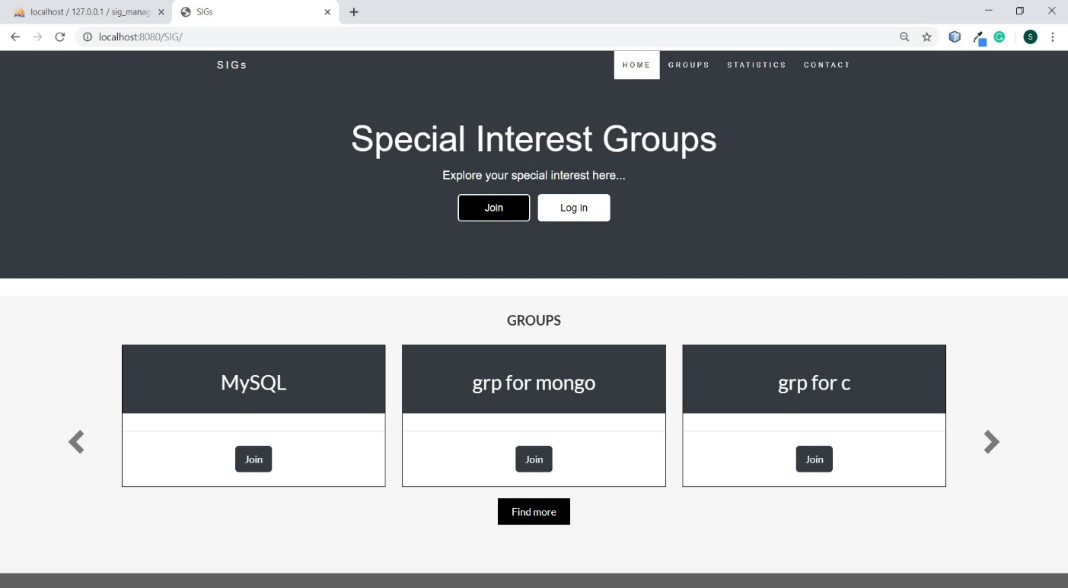

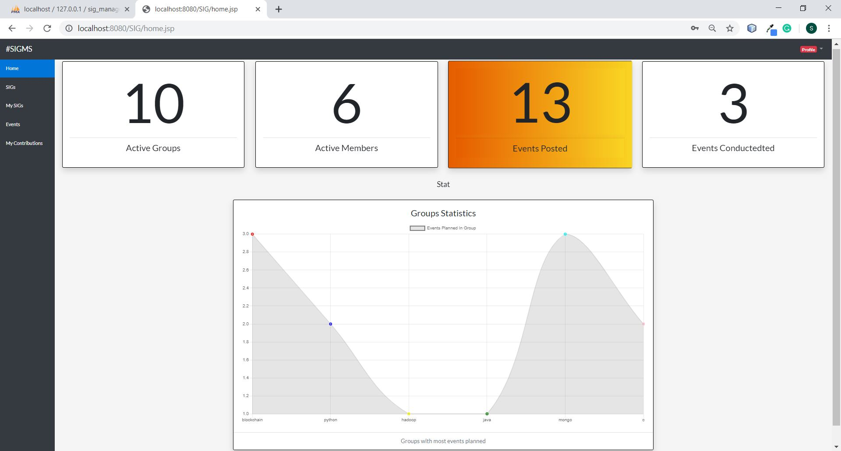

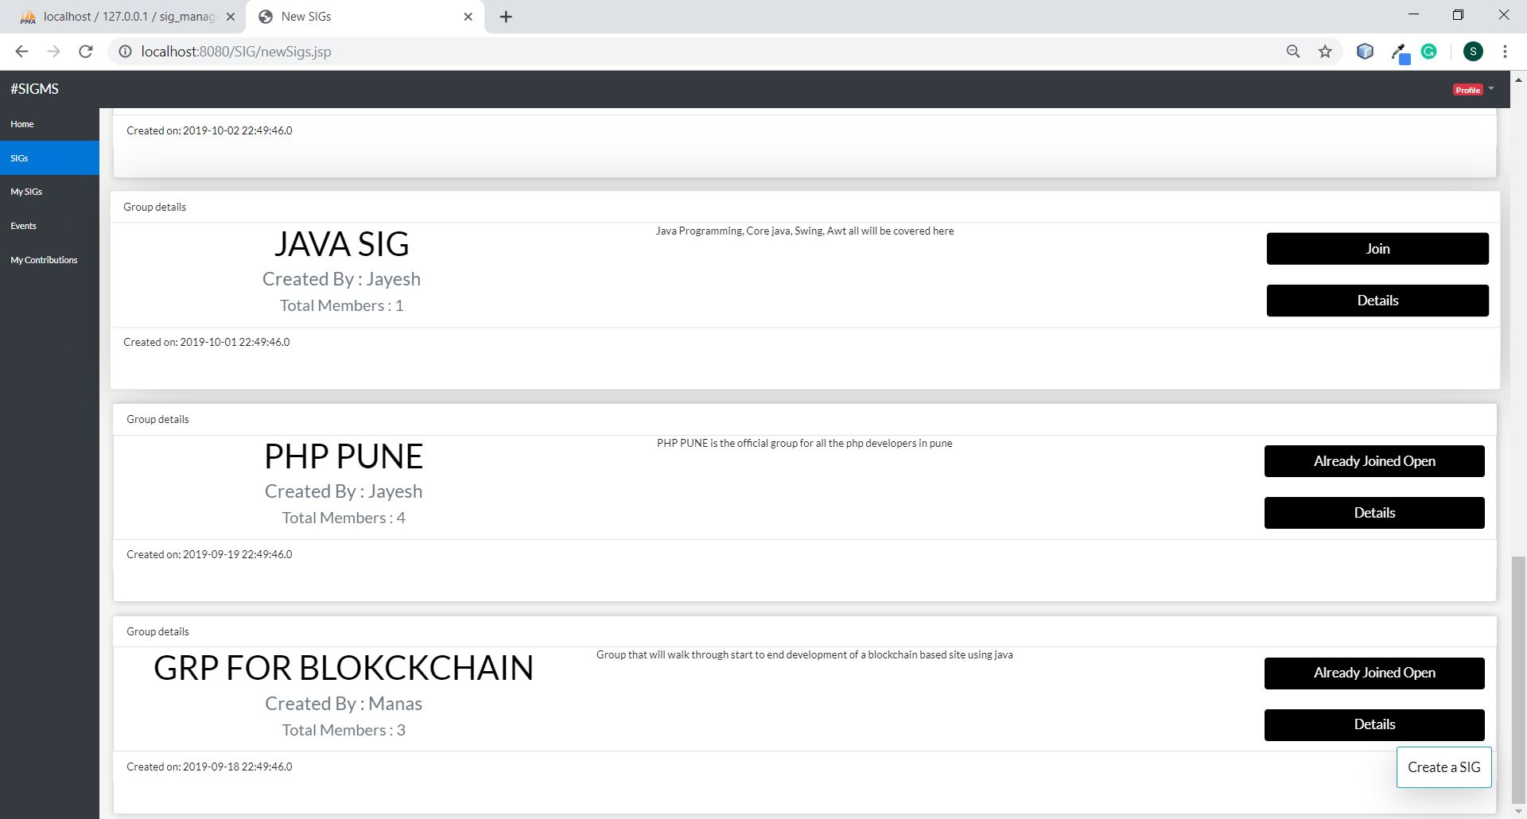

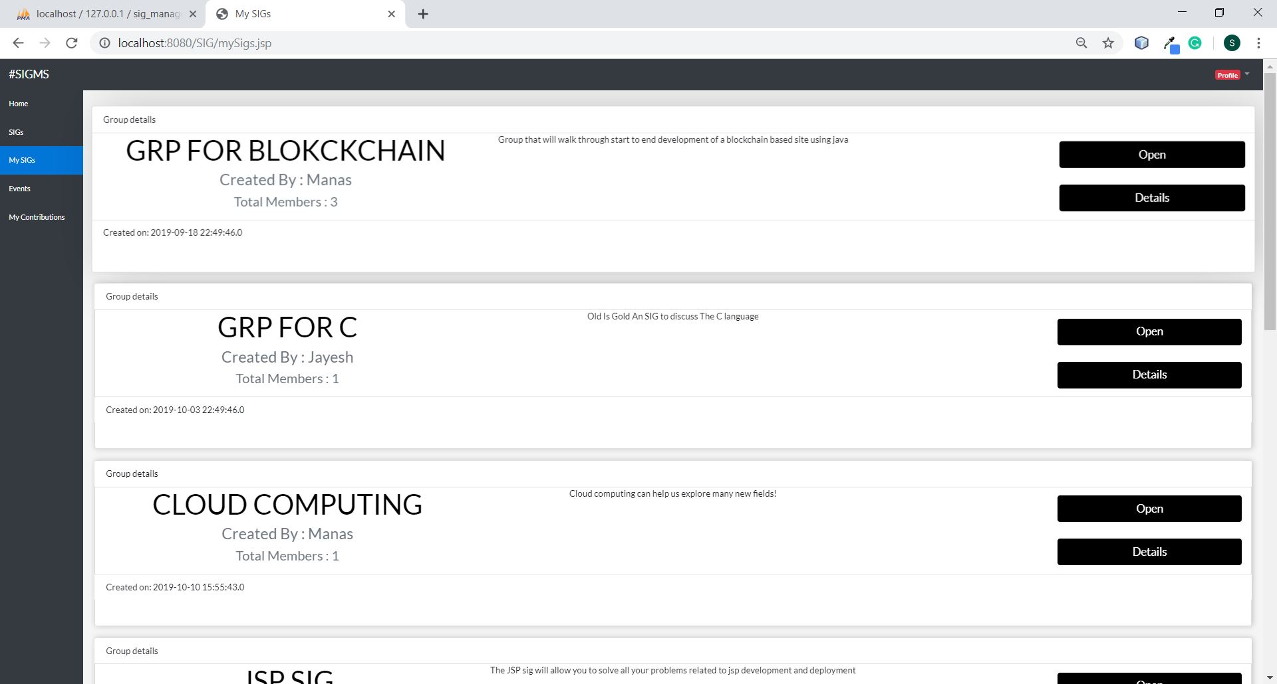

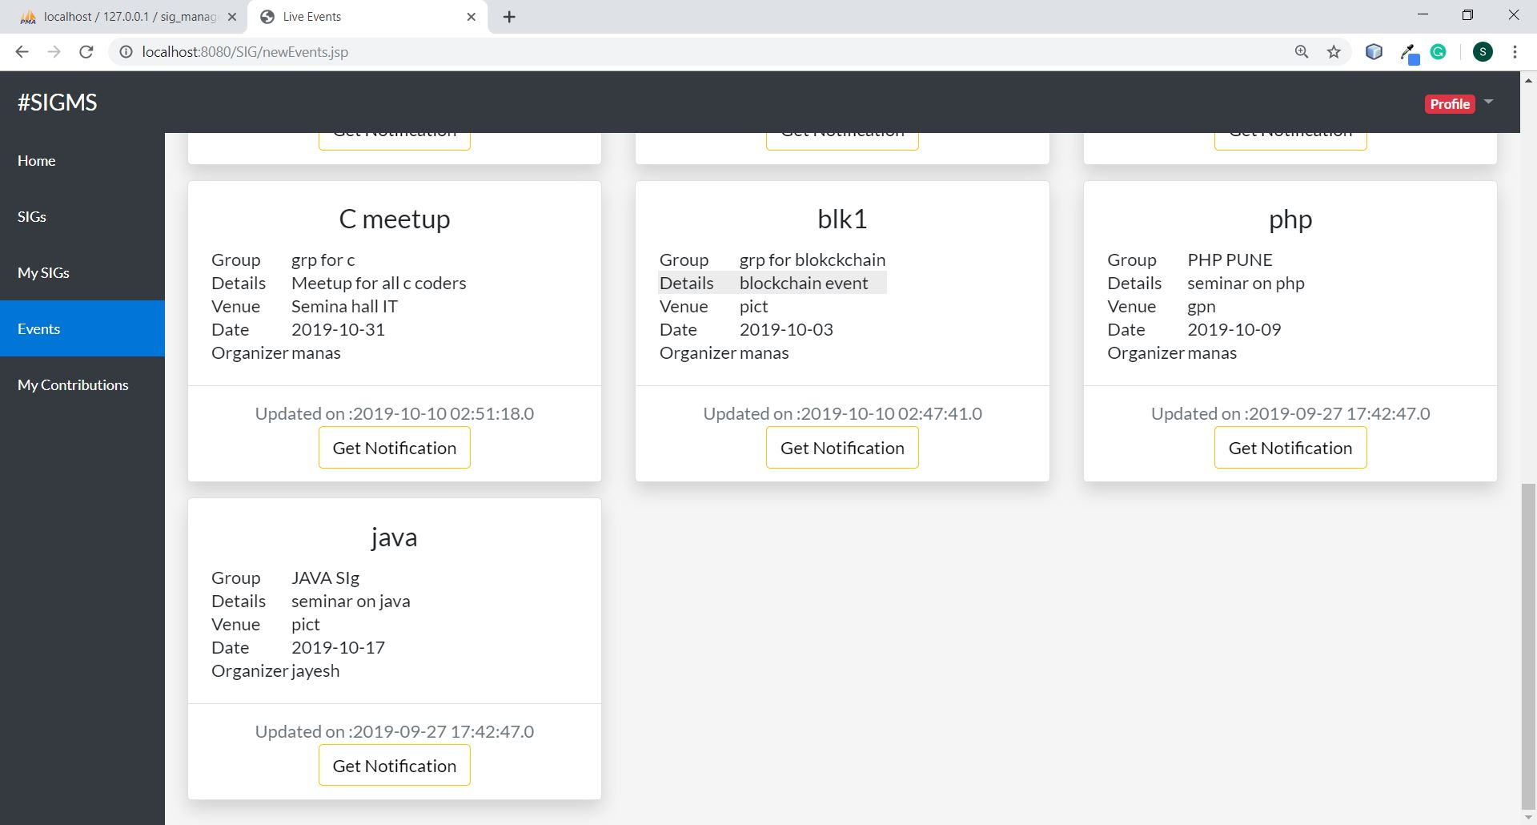

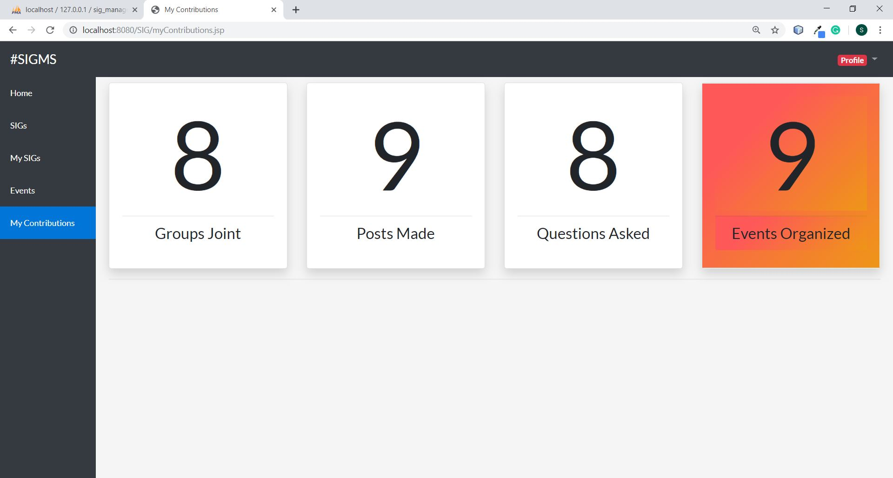

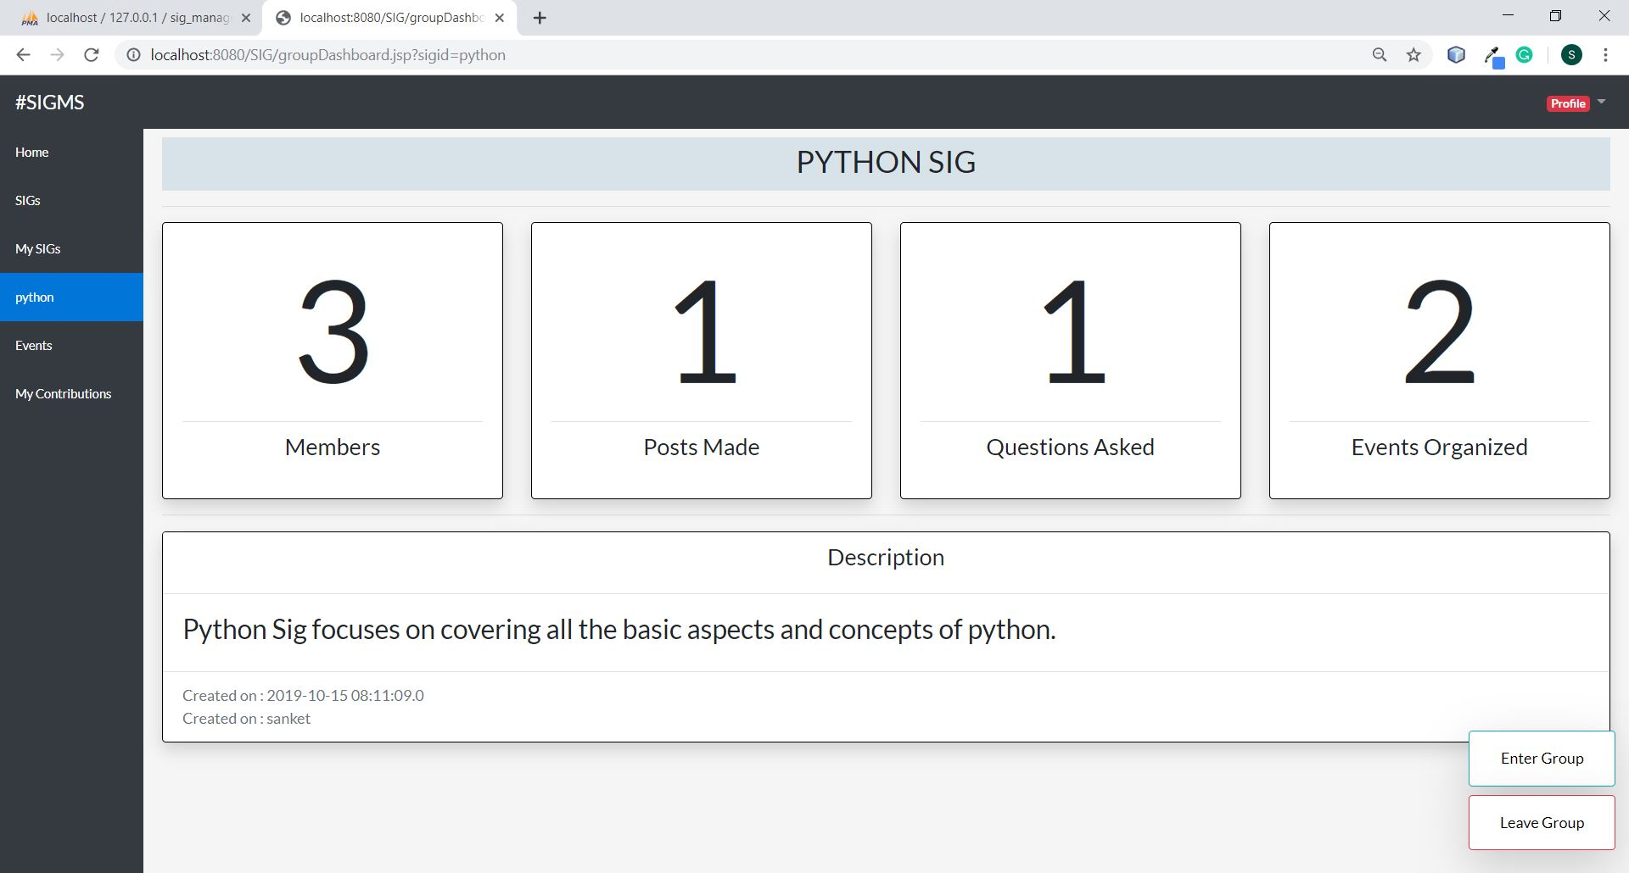

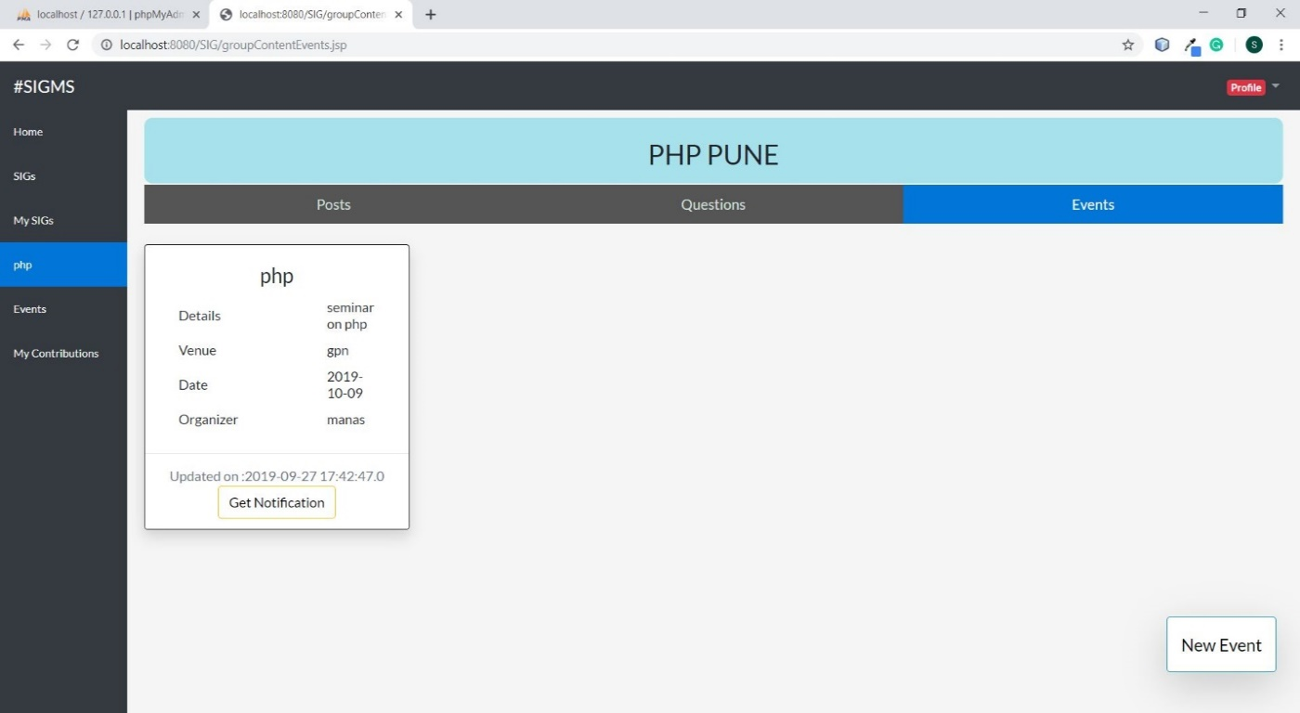

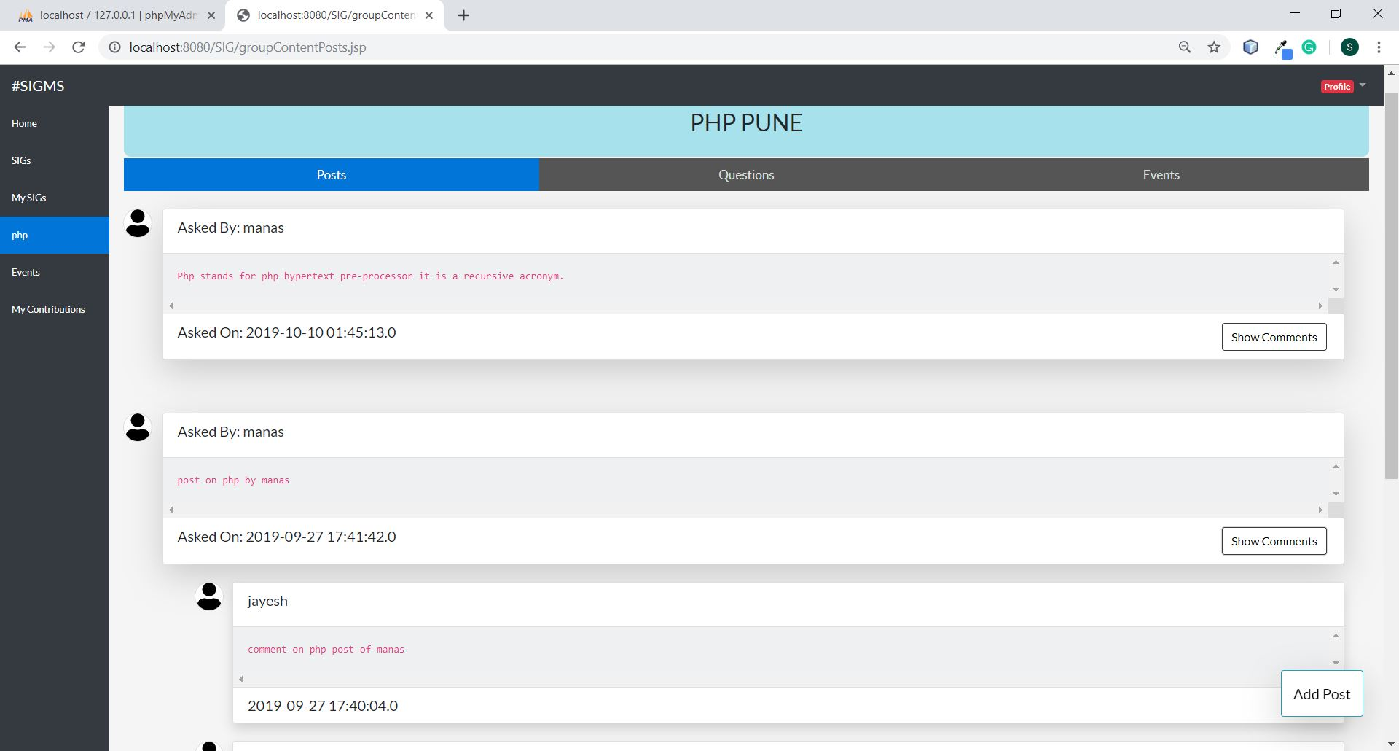

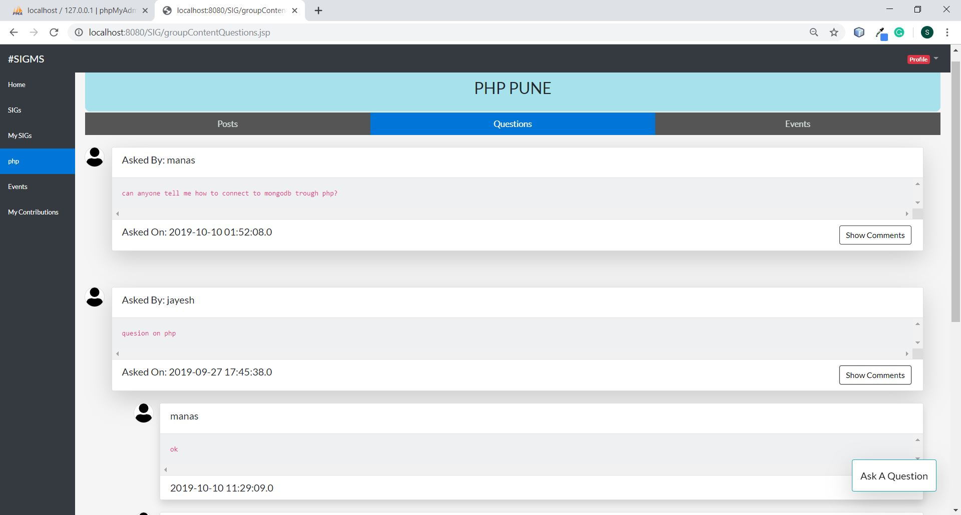

**CONCLUSION**

Thus, this platform helps us to resolve the various problems of respective fields with the help of group members. Anyone may create a group, but the admin retains full control over the group content, along with administrative abilities such as endorsing good answers and viewing more detailed statistics on group activity.

In this system, user also can add the event within the field, so that group members are notified about that event. This platform can also be useful for advertising purpose.

**REFERENCES**

* <https://docs.oracle.com/cd/E17802_01/products/products/servlet/2.5/docs/servlet-2_5-mr2/>
* <https://dev.mysql.com/doc/>
* <https://getbootstrap.com/docs/4.0/getting-started/introduction/>
* <https://www.chartjs.org/docs/latest/>